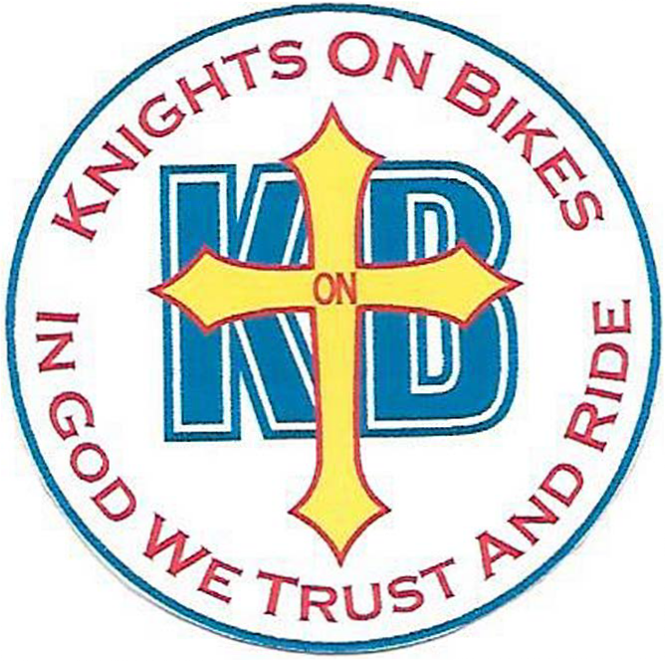
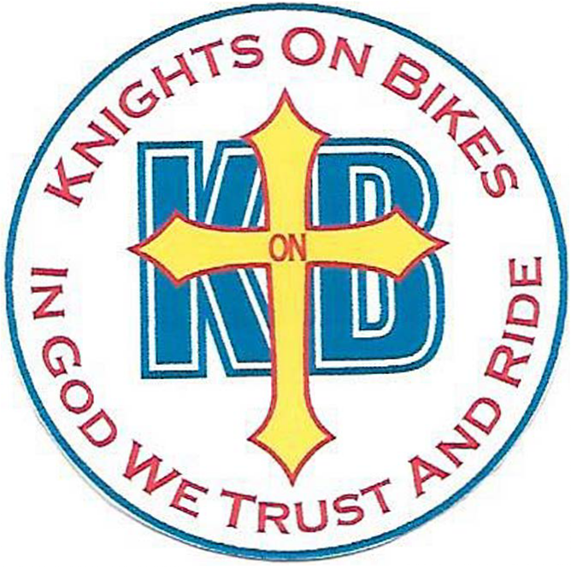
Knights On Bikes

State of Florida - Membership Application
eMail to: konbflmembership@gmail.com and KonBFLPresident@gmail.com

Full Name: Sir Knight? Yes / No Full Address (NO P.O. Boxes:) City: State: FL Postal Code: Mobile Phone (Primary Contact): Home Phone: Email: Work Phone:
Diocese: Parish:
===================================================================

Knights on Bikes Proposer Name: Knights on Bikes Proposer Phone Number:

Signature Date
==================================================================

Describe your involvement with your parish and your council:

==================================================================

Knights of Columbus Information:

Traveling/Membership Card Number: Degree: Council #
Date Admitted to the KofC: Council Name: Council Contact Person & Phone #: Assembly Name and Assembly #: Assembly Contact Person & Phone #: You MUST send photocopies of your current KofC Membership Cards (front & back)

for verification of your membership status!!
ATTESTATION
I, , Attest and Affirm that I am a Knights of Columbus IN GOOD STANDING, and that I AM PROPERLY and FULLY LICENSED (attach copy) to OPERATE a MOTORCYCLE; that I am TRAINED/SKILLED in such operation of ANY motorcycle I will use while riding as a Knight on Bike (KonB), whether or not I am wearing Knights of Columbus patches/attire; and I hereby RELEASE and HOLD HARMLESS The Holy Catholic Church, The Knights of Columbus, and/or The Knights on Bikes, either in whole, as a group, or individually, from ANY adverse action, injury, or loss, to myself, or to others, that may have been caused directly, or indirectly by me, or ANY OTHER participant in a Knights on Bikes, Knights of Columbus and/or Holy Catholic Church function; or ANY OTHER function I participate in involving the use of motorcycles. I further attest that I have the proper insurance (attach copy of insurance card) and will maintain this insurance for as long as a I participated in the Knights on Bikes. Following membership and candidacy period approval, I may purchase KonB patches with the understanding and acceptance that the Diocese Crest and Gold Cross are the property of the Knights on Bikes and must be returned {without reimbursement} upon written request by the Diocese Chairman or National President.
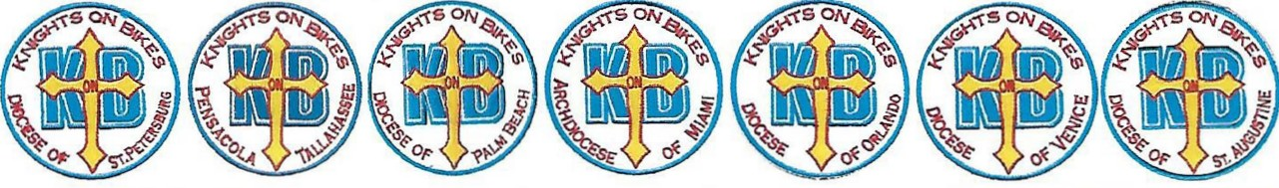
Signature: Date:

Scan code to learn more. Ver. 2023.03.29

